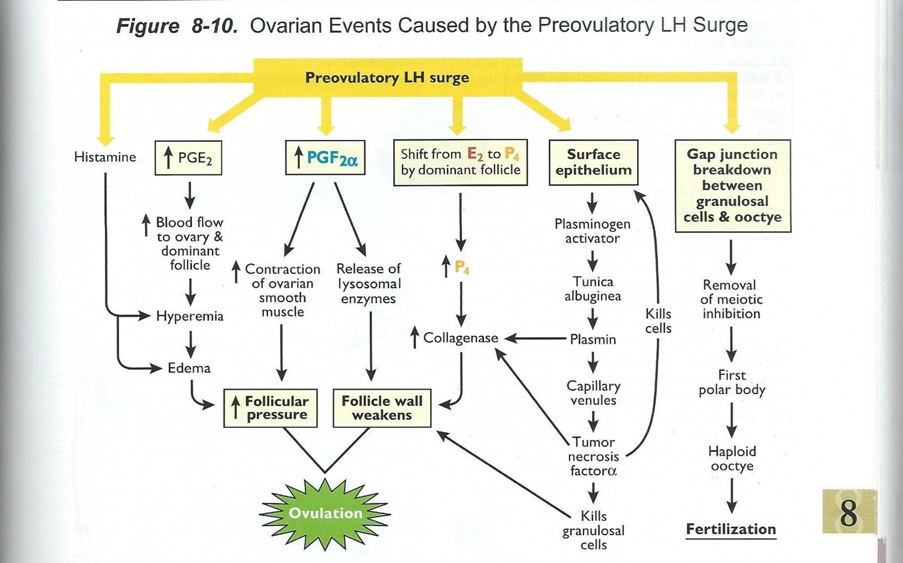

Label the order for: Destruction of follicular tissue

1) Hyperemia -> Histamine and PGE2 drive the increase in blood flow
2) Dominant Follicle -> angiogenic factors in follicular fluid
3) Progesterone production prior to ovulation
    - Theca cells start making; closer to ovulation granulosa cells start making
    - Progesterone increases production of collagenase
4) Prostaglandin (PGF2a and PGFE2)
5) Proteases made -> used to get the oocyte out

Define the following:

Edema – swelling

Hyperemia – increased blood flow

The LH surge stimulates the cumulus oorphus cells to produce hyaluronic acid which causes expansion of the COC -> increases surface area

