Difference in Estrous and Estrus

% of time in the follicular stage? Luteal stage?

What is the primary ovarian structure during the luteal phase?

Since we know the dominant ovarian structure during the luteal phase is the CL, what could the dominant ovarian steroid hormone be?

What does it mean for horses to be long day breeders?

What does it mean for ewes and does to be short day breeders?

Explain what happens to the hormone profile of a cow while she is gestating:

Label the chart with the following:
Luteal Phase, Follicular Phase, Metestrus, Estrus, Proestrus, Diestrus, Ovulation, Progesterone, Estrogen, Corpus Luteum, Dominant Follicle, Estrous

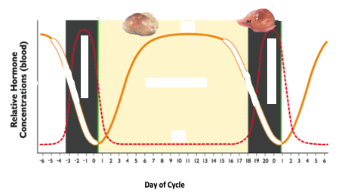

Determine the type and length of the following female’s cycle and lastly, length of pregnancy?

Cow:

Ewe:

Sow:

Mare:

When does ovulation occur for the following females?

Cow:

Ewe:

Sow:

Mare:

