What’s order of embryonic development?

What has to happen for an embryo to continue growth?

What is the maternal recognition for cattle and sheep? Pigs?

What is gestation?
- The act of carrying or being carried
- Pregnancy
- Mothering ability
- A & B are correct

What are the general portions of placentation?

Implantation can happen a few different ways. What species does the conceptus “bury” itself into the uterine endometrium?

What makes up a placentome?

What part of the placenta is made up of fetal tissue? Maternal tissue?

What species do these placentomes come from?

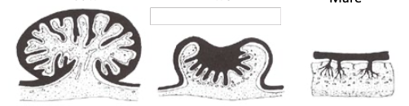

Match the following terms to the correct species and description:

Diffuse Zonary Discoid Cotyledonary

- Placentas have a band-like zone of chorionic villi ; cats and dogs
- Numerous, discrete button-like structures ; ruminants
- Uniform distribution of chorionic villi ; mare and sows
- Placenta form a regionalized disc ; rodent and primates

The placenta is the _________ that transports nutrients, respiratory gases and waste between the maternal and fetal systems. It also serves as a transient ____________ organ that can produce a variety of hormones that are important for pregnancy and the onset of ___________

Name the different types of placenta in order of least intimate to most intimate.

Why is the order the way that it is?

What are some hormones produced by the placenta?

What does placental P4 and estrogen do?

What does placental lactogen do?

What does placental relaxin do?

Fill in the following table:

Species | Gestation Length | Time of Placental Takeover
 | 9 months | 6-8 months
 | 5 months | 50 days
Goat | 5 months
Mare |  | None
Sow |  | None
Woman | 9 months

