|  |  |  |  |
| --- | --- | --- | --- |
| Gland: | Hormone: | Chemical Class: | Principle Function: |
| Ovary | Estrogen |  | Mating behavior; secondary sex characteristics; maintenance of female duct system |
| Ovary |  | Steroid | Precursor of estrogen |
| Ovary | Progesterone |  | Maintains pregnancy; mammary growth; inhibits myometrial contractions |
| Testes | Testosterone (androgens) | Steroid |  |
| Placenta |  | Steroid | *see ovary section |
| Uterine Endometrium |  | FA/Lipid | Causes regression of CL; stimulates myometrial contractions; ovulation |
| Seminal Vesicles | PGF2A | FA/Lipid |  |
| Pineal |  | Biogenic Amine |  |
| Posterior Pituitary | Oxytocin | Peptide |  |
| Anterior Pituitary |  | Glycoprotein | Stimulates follicle growth, estrogen production, spermatogenesis |
| Anterior Pituitary |  | Glycoprotein | Stimulate ovulation; supports CL formation and progesterone secretion; stimulates testosterone synthesis by Leydig cells of the testis |
| Hypothalamus | Gonadotropin Releasing Hormone (GnRH) | Peptide |  |
| Hypothalamus | Oxytocin | Peptide | Produced by hypothalamus, released by posterior pituitary |

These are other important hormones that play a role in reproduction:

|  |  |  |  |
| --- | --- | --- | --- |
| Gland: | Hormone: | Chemical Class: | Principle Function: |
| Ovary |  | Protein | Inhibits the release of FSH from anterior pituitary |
| Ovary | Relaxin (Sow CL) | Protein | Expands the pelvis; dilation of cervix for parturition |
| Testis |  | Protein | Inhibits the release of FSH from anterior pituitary |
| Adrenal Cortex | Glucocorticoids  Corticosteroids (Cortisol) | Steroid | Induction of parturition by fetus; milk synthesis; stress responses |
| Placenta | Human Chorionic Gonadotrophin | Glycoprotein | LH-like involvement with establishment of pregnancy in women; supports & maintains CL |
| Placenta | Equine Chorionic Gonadotropin | Glycoprotein | FSH-like (some LH) activity; immunological protection of foal during pregnancy; formation of accessory CLs |
| Placenta |  | Protein | Relaxation/dilation of cervix for parturition |
| Placenta | Placental Lactogen | Glycoprotein | Maintains CL; stimulates mammary growth & milk secretion |
| Liver | Insulin-like Growth Factors (IGF-1 and IGF-2) | Protein | Stimulates steroidogenesis; mammary growth; fetal growth |
| Anterior pituitary |  | Protein | Stimulates milk synthesis; regulate metabolism for milk synthesis; effect maternal behavior |
| Anterior pituitary | Growth Hormone (GH) | Protein | Stimulates milk synthesis through IGF-1 secretion |
| Anterior pituitary | Adrenalcorticotropic Hormone (ACTH) | Protein | Release of corticosteroids and glucocorticoids from adrenal cortex initiate parturition |
| Hypothalamus | Dopamine | Biogenic Amine | Inhibits release of prolactin |
| Hypothalamus | Corticotropic Releasing Hormone (CRH) | Peptide | Stimulates ACTH |
| Hypothalamus | Growth Hormone Releasing Factor (GHR) | Peptide | Stimulates release of Growth Hormone |

Match the following to the correct terms:

Peptide Protein Glycoprotein Steroids Lipids Biogenic Amine

1. Long chains of amino acids
2. Cholesterol is the precursor
3. Few to several amino acids
4. Protein hormone with carbohydrate molecules
5. Derived from Tyrosine or Tryptophan
6. From Arachidonic Acid

How many Carbons are found within Cholesterol? Progesterone? Estrogen? Testosterone?

For the brain to become “femininized” what has to enter the brain?

What hormones can travel freely in the blood?

What has to have a carrier protein?

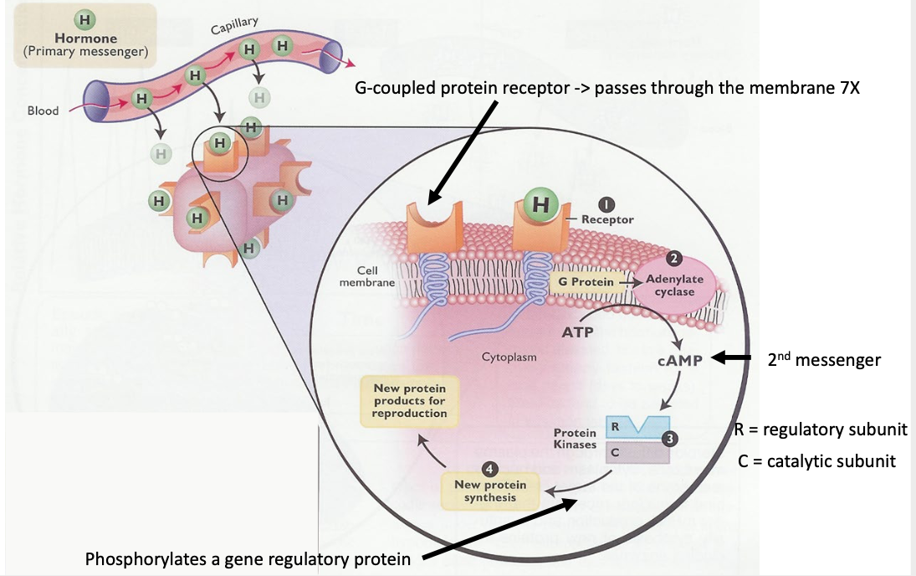Let’s talk Hormone Mechanisms of Action!!

Slow response:

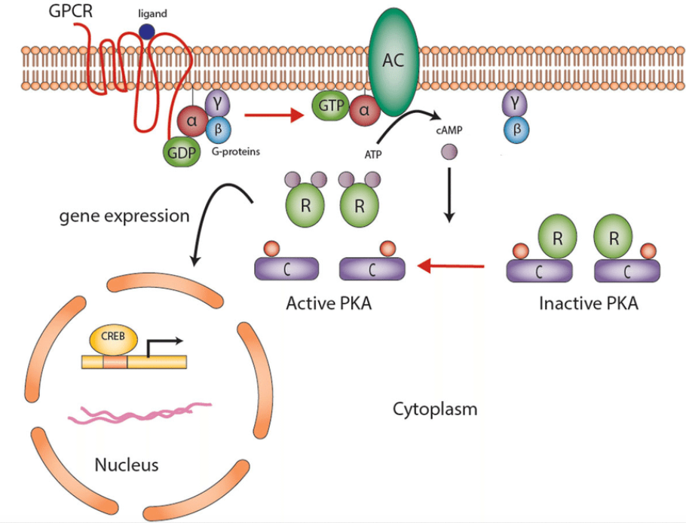

Fast Response:

