Let’s walk through this…
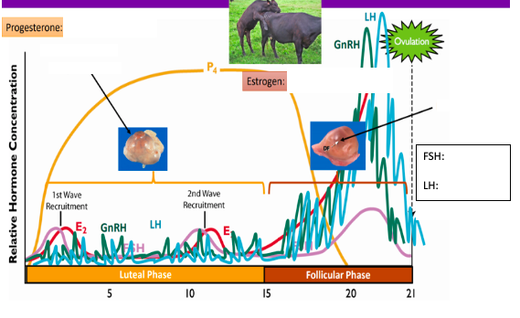

Feedback Signals:
Positive feedback: stimulus continues until goal is reached
E2 Hypothalamus = more GnRH = More LH/FSH

Negative feedback: stimulus prevents/inhibits the same stimulus= decrease in stimulus
Progesterone increases = LH/FSH to decrease

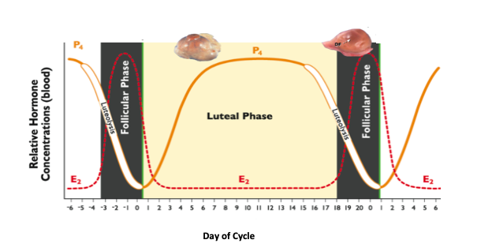

Label the graph above where proestrus, diestrus, metestrus, and estrus occur as well as when ovulation will happen.

Define the following:

Estrous (adj.)-

Luteal phase-

Metestrus-

Diestrus-

Follicular phase-

Proestrus-

Estrus-

Seasonal polyestrus-

Anestrus-

True-

Apparent-

Polyestrus-

Monoestrus-

What is the primary ovarian structure during the follicular phase?
- Uhh… honestly, IDK
- A primary follicle
- A graafian follicle
- Growing follicles
- None of the above

What is the dominant ovarian steroid hormone during the follicular phase?
- Progesterone
- Relaxin
- Oxytocin
- Estrogen

Which of the following is the primary ovarian structure during the luteal phase?
- An antral follicle
- Corpus Hemorrhagicum
- Corpus Albicans
- Corpus Luteum

Since we know the dominant ovarian structure during the luteal phase is the CL, what could the dominant ovarian steroid hormone be?
- GnRH
- Progesterone
- Estrogen
- Relaxin

Describe the following types of anestrus:

Gestational:

Lactational:

Nutritional:

Let’s talk hormones!
Hormone: | Synthesis: | Site of Action
GnRH
FSH
LH
Estrogen
Progesterone
PGF2a
Testosterone

