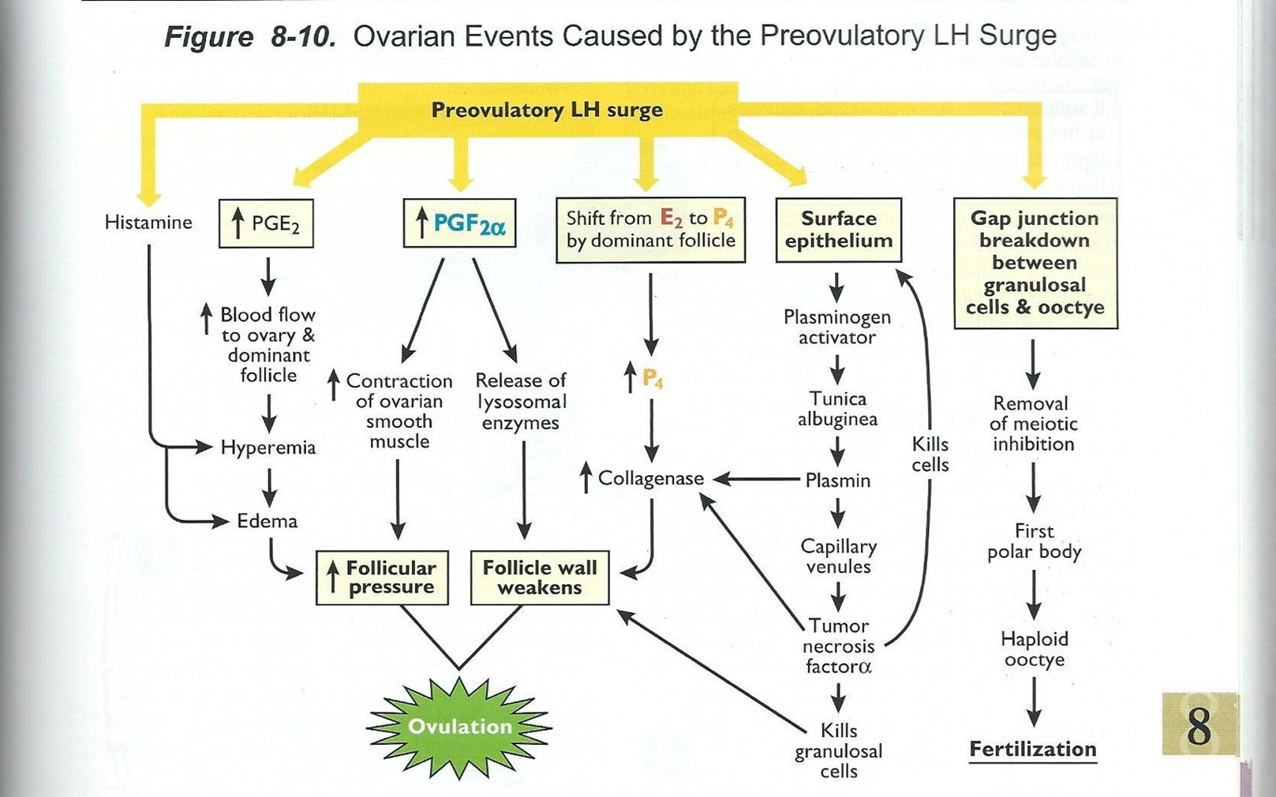

Label the order for: Destruction of follicular tissue

Prostaglandin (PGF2a and PGFE2)
Hyperemia -> Histamine and PGE2 drive the increase in blood flow
Progesterone production prior to ovulation
    - Theca cells start making; closer to ovulation granulosa cells start making
    - Progesterone increases production of collagenase

Proteases made -> used to get the oocyte out
Dominant Follicle -> angiogenic factors in follicular fluid

Define the following:

Edema –

Hyperemia –

The LH surge stimulates the ____________ cells to produce hyaluronic acid which causes expansion of the COC -> _________ surface area

