Gland: | Hormone: | Chemical Class: | Principle Function:
Ovary | Estrogen |  | Mating behavior; secondary sex characteristics; maintenance of female duct system
Ovary |  | Steroid | Precursor of estrogen
Ovary | Progesterone |  | Maintains pregnancy; mammary growth; inhibits myometrial contractions
Testes | Testosterone (androgens) | Steroid
Placenta |  | Steroid | *see ovary section
Uterine Endometrium |  | FA/Lipid | Causes regression of CL; stimulates myometrial contractions; ovulation
Seminal Vesicles | PGF2A | FA/Lipid
Pineal |  | Biogenic Amine
Posterior Pituitary | Oxytocin | Peptide
Anterior Pituitary |  | Glycoprotein | Stimulates follicle growth, estrogen production, spermatogenesis
Anterior Pituitary |  | Glycoprotein | Stimulate ovulation; supports CL formation and progesterone secretion; stimulates testosterone synthesis by Leydig cells of the testis
Hypothalamus | Gonadotropin Releasing Hormone (GnRH) | Peptide
Hypothalamus | Oxytocin | Peptide | Produced by hypothalamus, released by posterior pituitary

Let’s talk about Hormones! These are ones we have already talked about throughout the semester:

These are other important hormones that play a role in reproduction:
Gland: | Hormone: | Chemical Class: | Principle Function:
Ovary |  | Protein | Inhibits the release of FSH from anterior pituitary
Ovary | Relaxin (Sow CL) | Protein | Expands the pelvis; dilation of cervix for parturition
Testis |  | Protein | Inhibits the release of FSH from anterior pituitary
Adrenal Cortex | Glucocorticoids  Corticosteroids (Cortisol) | Steroid | Induction of partiurtion by fetus; milk synthesis; stress responses
Placenta | Human Chorionic Gonadotrophin | Glycoprotein | LH-like involvement with establishment of pregnancy in women; supports & maintains CL
Placenta | Equine Chorionic Gonadotropin | Glycoprotein | FSH-like (some LH) activity; immunological protection of foal during pregnancy; formation of accessory CLs
Placenta |  | Protein | Relaxation/dilation of cervix for parturition
Placenta | Placental Lactogen | Glycoprotein | Maintains CL; stimulates mammary growth & milk secretion
Liver | Insulin-like Growth Factors (IGF-1 and IGF-2) | Protein | Stimulates steroidogenesis; mammary growth; fetal growth
Anterior pituitary |  | Protein | Stimulates milk synthesis; regulate metabolism for milk synthesis; effect maternal behavior
Anterior pituitary | Growth Hormone (GH) | Protein | Stimulates milk synthesis through IGF-1 secretion
Anterior pituitary | Adrenalcorticotropic Hormone (ACTH) | Protein | Release of corticosteroids and glucocorticoids from adrenal cortex initiate parturition
Hypothalamus | Dopamine | Biogenic Amine | Inhibits release of prolactin
Hypothalamus | Corticotropic Releasing Hormone (CRH) | Peptide | Stimulates ACTH
Hypothalamus | Growth Hormone Releasing Factor (GHR) | Peptide | Stimulates release of Growth Hormone

Match the following to the correct terms:

Peptide Protein Glycoprotein Steroids Lipids Biogenic Amine

- Long chains of amino acids
- Cholesterol is the precursor
- Few to several amino acids
- Protein hormone with carbohydrate molecules
- Derived from Tyrosine or Tryptophan
- From Arachidonic Acid

How many Carbons are found within Cholesterol?

How many Carbons are found within Progesterone?

How many Carbons are found within Estrogen?

How many Carbons are found within Testosterone?

Since we know how many Carbons are in steroid hormones, label what structure is….

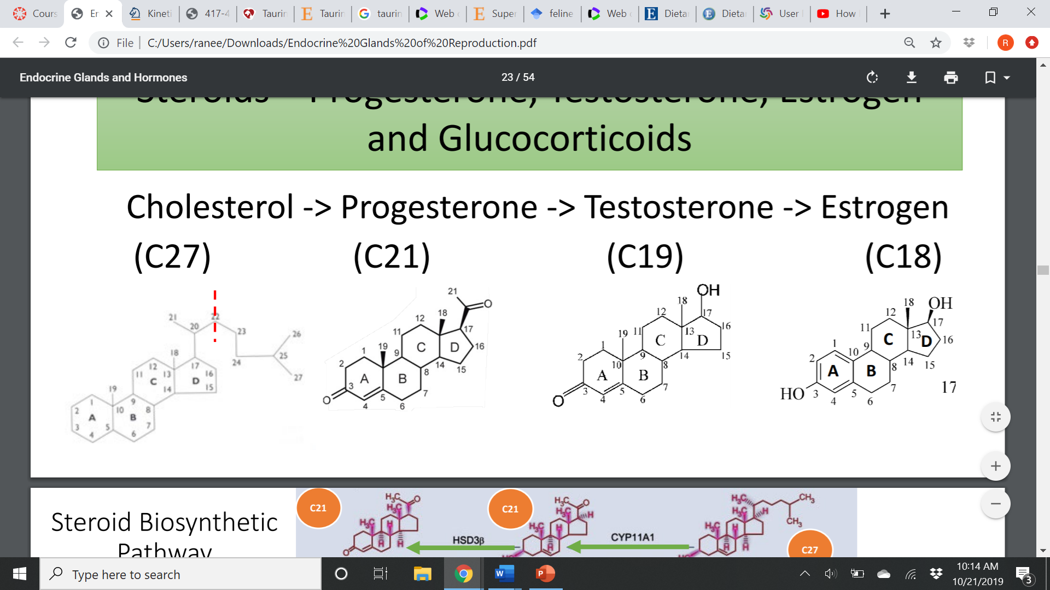

Match the following terms to the correct definition:

Autocrine Endocrine Paracrine

- Distant signaling with use of the circulatory system
- Signaling to nearby/adjacent cells
- Self-signaling

The endocrine system has 2 general control mechanisms. What are they?

For the brain to become “femininized” what has to enter the brain?

What hormones can travel freely in the blood?

What has to have a carrier protein?

