Uterine __________________ is required for luteolysis (Corpus Luteum regression/cell death). PGF2A is locally produced in the uterine ___________________ layer that ends up getting transported to the ovary through the _________________ ___________________ _________________ mechanism and from there it enters the corpus luteum without any _______________ from the systemic circulation.

About how much of PGF2A is metabolized in cows/ewes? What about sows?

Is it more effective to use exogenous PGF2A?

Where is exogenous PGF2A?

What is ALWAYS first in the phases of luteolysis?

How many hours after functional does structural luteolysis occur?

What is apoptosis?

Is PGF2A always there?

What increases the production of oxytocin?

PGF2A signaling results in decrease of what receptor(s) on luteal cells?

What cells in structural luteolysis die first? What about second?

True / False : The Uterus is not required for successful luteolysis to occur.

True / False : The Corpus Luteum has a high metabolic demand?

What happens if the female does not become pregnant?

Explain the steps for progesterone secretion:

PGF2A signaling in Luteal Cells:

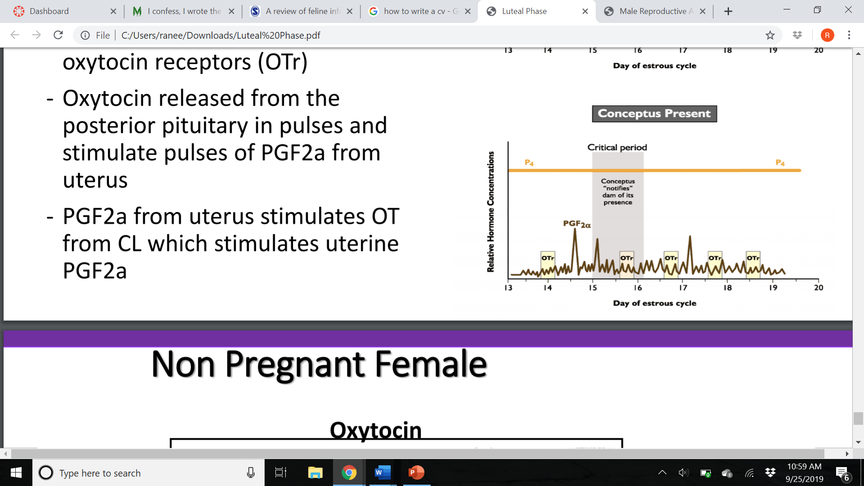
Explain luteal regression in ruminants:
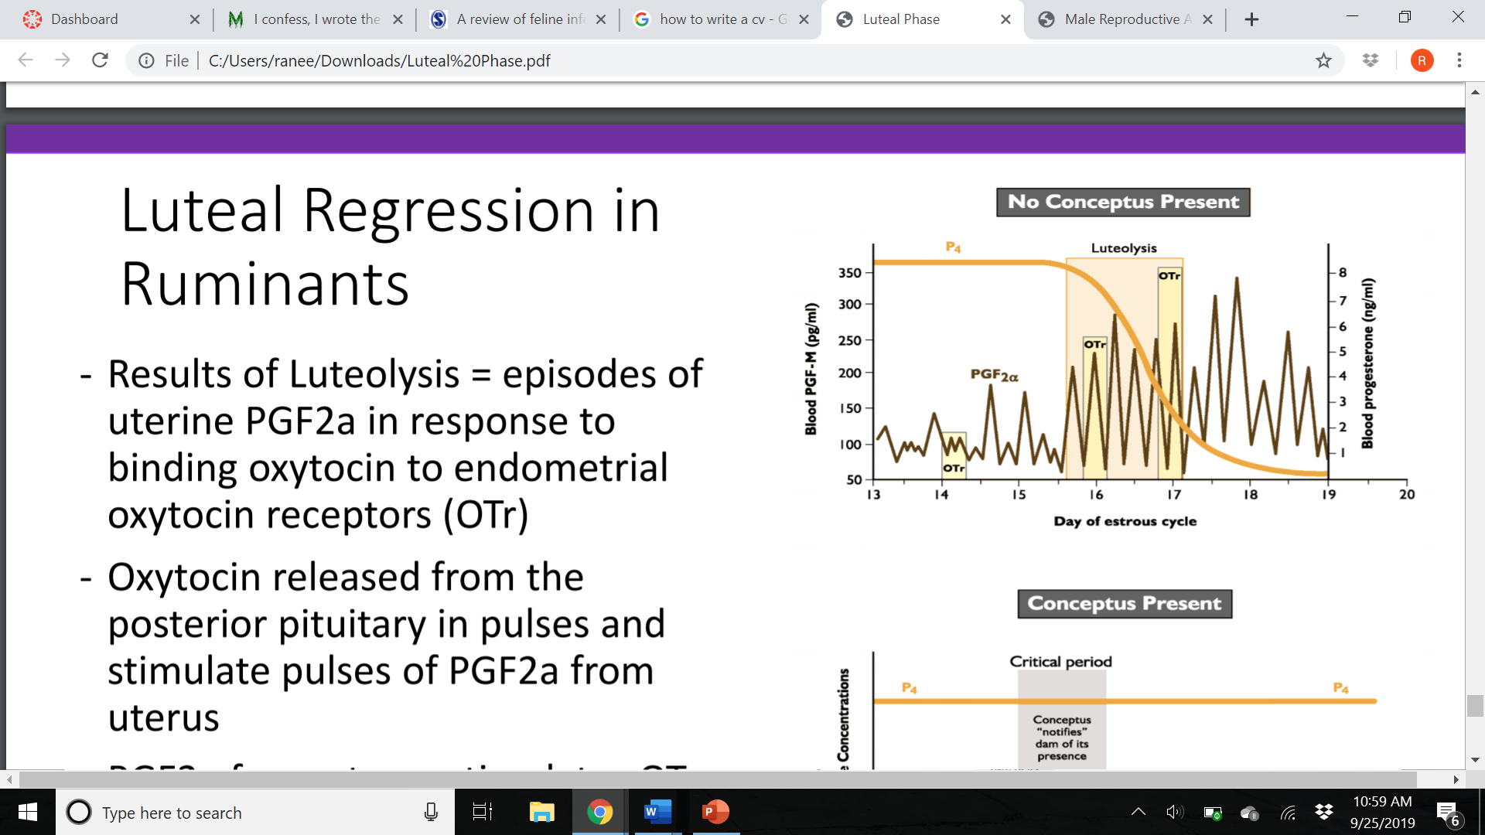

Let’s talk Functional and Structural Luteolysis:

Functional:

Structural:

