What animal does not have a fornix vagina?

What is considered the copulatory organ for a female?

Site of Semen deposition for….

Cow/Doe/Ewe-

Mare/Sow-

Let’s label a female reproductive tract:

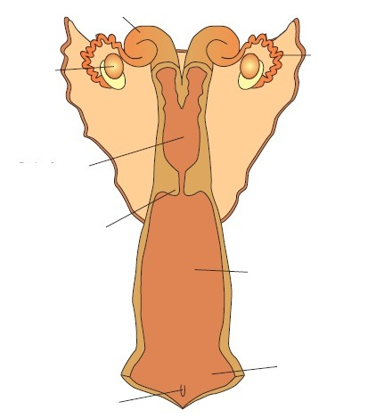

What do peristaltic contractions do within the uterus?

1. Expulsion of fetus
2. Sperm transport
3. Both A & B
4. None of the above

What gives rise to the maternal placenta in ruminants?

What contributes to maternal placenta in sows and mares?

What is a vehicle for sperm? Do sperm swim?

Describe sialomucin and what happens with sperm: *cervical mucus*

Describe sulfomucin and what happens to sperm: *cervical mucus*

Who are short day breeders? Who are long day breeders?

Match the following terms to their respective definition:

Seasonal Polyestrus Polyestrus Anestrus Monoestrus

1. Female displays estrous cycles uniformly distributed throughout the year without any seasonal influence
2. A period of anestrus induced by length of day
3. Female displays only one period of sexual receptivity
4. When a female does not display estrus (standing heat)

Estrogen brings on what?

Progesterone is the _______________ hormone and it is maintained by this.

Let’s work through this:

What is the primary ovarian structure during the follicular phase?

What is the dominant ovarian steroid hormone of the follicular phase?

Describe the following types of anestrus:

Gestational:

Lactational:

Nutritional: